**SOFT COMPUTING**

**ASSIGNMENT -2**

**Perumalla Dharan**

**AP21110010201**

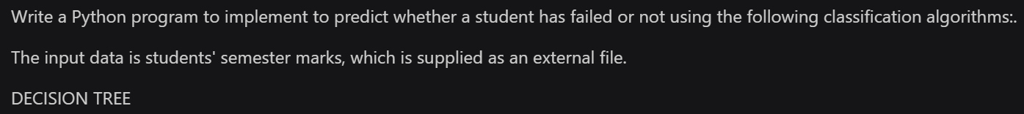

*import* pandas *as* pd

*from* sklearn.model_selection *import* train_test_split

*from* sklearn.tree *import* DecisionTreeClassifier

*from* sklearn.neighbors *import* KNeighborsClassifier

*from* sklearn.svm *import* SVC

*from* sklearn.linear_model *import* Perceptron

*from* sklearn.metrics *import* accuracy_score, classification_report

data = pd.read_csv('training_dataset_students(1000).csv')

y = data.iloc[:, -1].values

X = data.iloc[:, 1:-1].values

X_train, X_test, y_train, y_test = train_test_split(X, y, *test_size*=0.3, *random_state*=42)

dt_model = DecisionTreeClassifier()

dt_model.fit(X_train, y_train)

y_pred_dt = dt_model.predict(X_test)

print("Decision Tree:")

print("Accuracy:", round(accuracy_score(y_test, y_pred_dt)*100,2),"%")

data = pd.read_csv('students_testing.csv')

new_data = data.iloc[:, 1:-1].values

print(new_data)

pred_dt_new = dt_model.predict(new_data)

print("\nDecision Tree Prediction for New Data:", pred_dt_new)

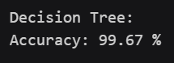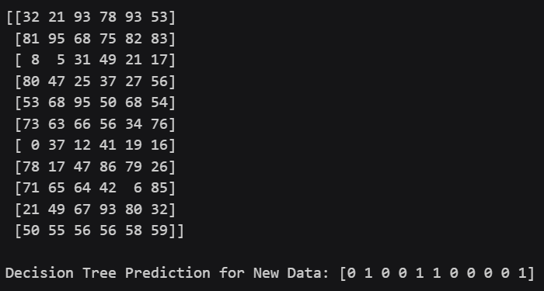

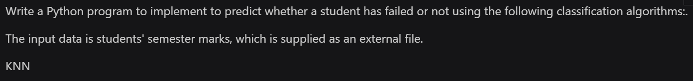

*import* pandas *as* pd

*from* sklearn.model_selection *import* train_test_split

*from* sklearn.tree *import* DecisionTreeClassifier

*from* sklearn.neighbors *import* KNeighborsClassifier

*from* sklearn.svm *import* SVC

*from* sklearn.linear_model *import* Perceptron

*from* sklearn.metrics *import* accuracy_score, classification_report

data = pd.read_csv('training_dataset_students(1000).csv')

y = data.iloc[:, -1].values

X = data.iloc[:, 1:-1].values

X_train, X_test, y_train, y_test = train_test_split(X, y, *test_size*=0.3, *random_state*=42)

knn_model = KNeighborsClassifier()

knn_model.fit(X_train, y_train)

y_pred_knn = knn_model.predict(X_test)

print("\nKNN:")

print("Accuracy:", round(accuracy_score(y_test, y_pred_knn)*100,2),"%")

data = pd.read_csv('students_testing.csv')

new_data = data.iloc[:, 1:-1].values

print(new_data)

pred_knn_new = knn_model.predict(new_data)

print("KNN Prediction for New Data:", pred_knn_new)

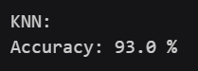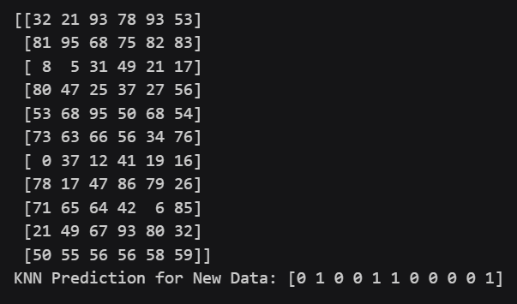

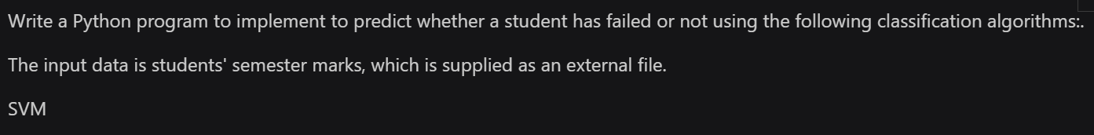

*import* pandas *as* pd

*from* sklearn.model_selection *import* train_test_split

*from* sklearn.tree *import* DecisionTreeClassifier

*from* sklearn.neighbors *import* KNeighborsClassifier

*from* sklearn.svm *import* SVC

*from* sklearn.linear_model *import* Perceptron

*from* sklearn.metrics *import* accuracy_score, classification_report

data = pd.read_csv('training_dataset_students(1000).csv')

y = data.iloc[:, -1].values

X = data.iloc[:, 1:-1].values

X_train, X_test, y_train, y_test = train_test_split(X, y, *test_size*=0.3, *random_state*=42)

svm_model = SVC()

svm_model.fit(X_train, y_train)

y_pred_svm = svm_model.predict(X_test)

print("\nSVM:")

print("Accuracy:", round(accuracy_score(y_test, y_pred_svm)*100,2),"%")

data = pd.read_csv('students_testing.csv')

new_data = data.iloc[:, 1:-1].values

print(new_data)

pred_svm_new = svm_model.predict(new_data)

print("SVM Prediction for New Data:", pred_svm_new)

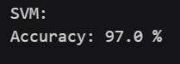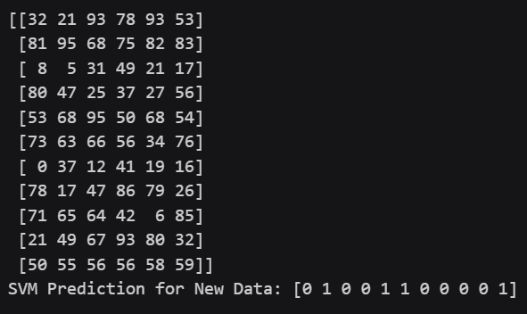

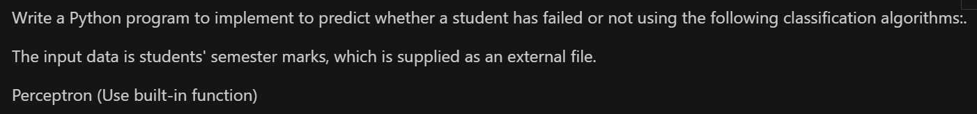

*import* pandas *as* pd

*from* sklearn.model_selection *import* train_test_split

*from* sklearn.tree *import* DecisionTreeClassifier

*from* sklearn.neighbors *import* KNeighborsClassifier

*from* sklearn.svm *import* SVC

*from* sklearn.linear_model *import* Perceptron

*from* sklearn.metrics *import* accuracy_score, classification_report

data = pd.read_csv('training_dataset_students(1000).csv')

y = data.iloc[:, -1].values

X = data.iloc[:, 1:-1].values

X_train, X_test, y_train, y_test = train_test_split(X, y, *test_size*=0.3, *random_state*=42)

perceptron_model = Perceptron()

perceptron_model.fit(X_train, y_train)

y_pred_perceptron = perceptron_model.predict(X_test)

print("\nPerceptron:")

print("Accuracy:", round(accuracy_score(y_test, y_pred_perceptron)*100,2),"%")

data = pd.read_csv('students_testing.csv')

new_data = data.iloc[:, 1:-1].values

print(new_data)

pred_perceptron_new = perceptron_model.predict(new_data)

print("Perceptron Prediction for New Data:", pred_perceptron_new)

